Technology Roadmap for Predictive ML + Generative AI + Agentic Systems
Research cutoff: September 11, 2026. The central recommendation is to preserve stable, typed service boundaries while progressively adding orchestration, policy, durability, and recovery controls. Do not replace deterministic software with agents merely because autonomy increases: Microsoft’s current framework guidance explicitly recommends workflows for well-defined steps—and ordinary functions when a function is sufficient—while LangGraph and Google ADK both support mixing deterministic logic with model-driven reasoning. [learn.microsoft.com], [docs.langchain.com], [adk.dev]

Phase-by-phase technology matrix
Phase | Application and orchestration | LLM, predictive ML, and knowledge | Decision and action layer | Operations, security, and governance
1. AI Assistant | Conventional API/web application; deterministic prompt/RAG pipeline; typed structured output. No agent framework required. | Managed LLM by default; document parsing, chunking, embeddings, hybrid retrieval, metadata filtering, citations. Start with PostgreSQL + pgvector when relational metadata and modest operational complexity matter; use OpenSearch/Elasticsearch or managed enterprise search when keyword search, ranking, connectors, and document permissions dominate. | No write tools. Input/output schema validation only. | OIDC, secrets manager, ACL-aware retrieval, prompt/version tracking, request tracing, answer/retrieval evaluation, cost and latency metrics.
2. Prediction-aware Assistant | Keep Phase 1 deterministic. Add a typed predictive-model client—not a general agent loop. | Versioned predictive endpoint plus probability/interval/uncertainty, feature timestamp, model version, and warnings. Add a feature store only when several models or online/offline feature consistency justify it. KServe defines portable inference, metadata, readiness, and version APIs; MLflow provides lineage, versioning, aliases, and rollback-oriented model management. [kserve.github.io], [mlflow.org], [learn.microsoft.com] | Thresholds and interpretation rules run in application code or a rules service; the LLM explains the result but cannot rewrite it. | Calibration, data/feature drift, delayed-outcome performance, endpoint SLOs, model lineage, and prediction-contract tests.
3. Recommendation Agent | Introduce an explicit graph/workflow with bounded agentic nodes: gather facts → call prediction → retrieve evidence → apply policy → optimize → explain recommendation. | Same LLM/RAG/ML services; add reranking, query decomposition only where measured, and structured recommendation evidence. Hybrid retrieval and multi-stage reranking are supported by Qdrant, OpenSearch, and Azure AI Search. | Add OPA or DMN/rules, plus OR-Tools/Pyomo/HiGHS for constrained optimization. Expose only read-only business tools. OPA separates policy decision from enforcement; OR-Tools covers constraint, linear, routing, graph, and mixed-integer use cases. [openpolicyagent.org], [github.com] | Agent trajectory traces, tool-selection/input tests, recommendation-quality and policy-compliance evaluation.
4. Human-approved Agent | Agent analyzes; durable workflow engine owns state and approval. Temporal or Camunda is the cloud-neutral default; agent frameworks remain inside analysis steps. | Same services as Phase 3. Freeze the evidence bundle presented for approval: recommendation, prediction, uncertainty, sources, policy result, intended action, and expiry. | Add write tools only behind approval, API gateway, policy enforcement, user-scoped identity, idempotency keys, transactional outbox, audit log, and compensating/rollback operations. Temporal persists waits and timers across worker restarts; Camunda provides assignable/claimable human tasks and task-list options. | Approval attribution, separation of duties, action replay protection, end-to-end audit, action-result verification.
5. Autonomous Agent | Retain a durable workflow/control plane; add a bounded observe–predict–plan–act loop with explicit stop conditions, budgets, maximum iterations, and circuit breakers. | Same knowledge and ML interfaces; add outcome/event ingestion and freshness constraints. Avoid unbounded self-modifying memory. | Automatic execution only for allowlisted, low-risk, reversible actions. Every action remains policy-checked, identity-bound, idempotent, observable, and rollback-capable. OWASP identifies excessive functionality, permissions, and autonomy as root causes of agent risk and recommends least privilege, downstream authorization, human approval for high-impact actions, and complete mediation. [genai.owasp.org], [genai.owasp.org] | Continuous online evaluation, anomaly detection, action budgets, canary/shadow execution, rollback rate, business-outcome monitoring, red-team testing, and kill switches. NIST’s 2026 initiative emphasizes secure agent identity, authorization, interoperability, and evaluation. [nist.gov], [atlas.mitre.org]
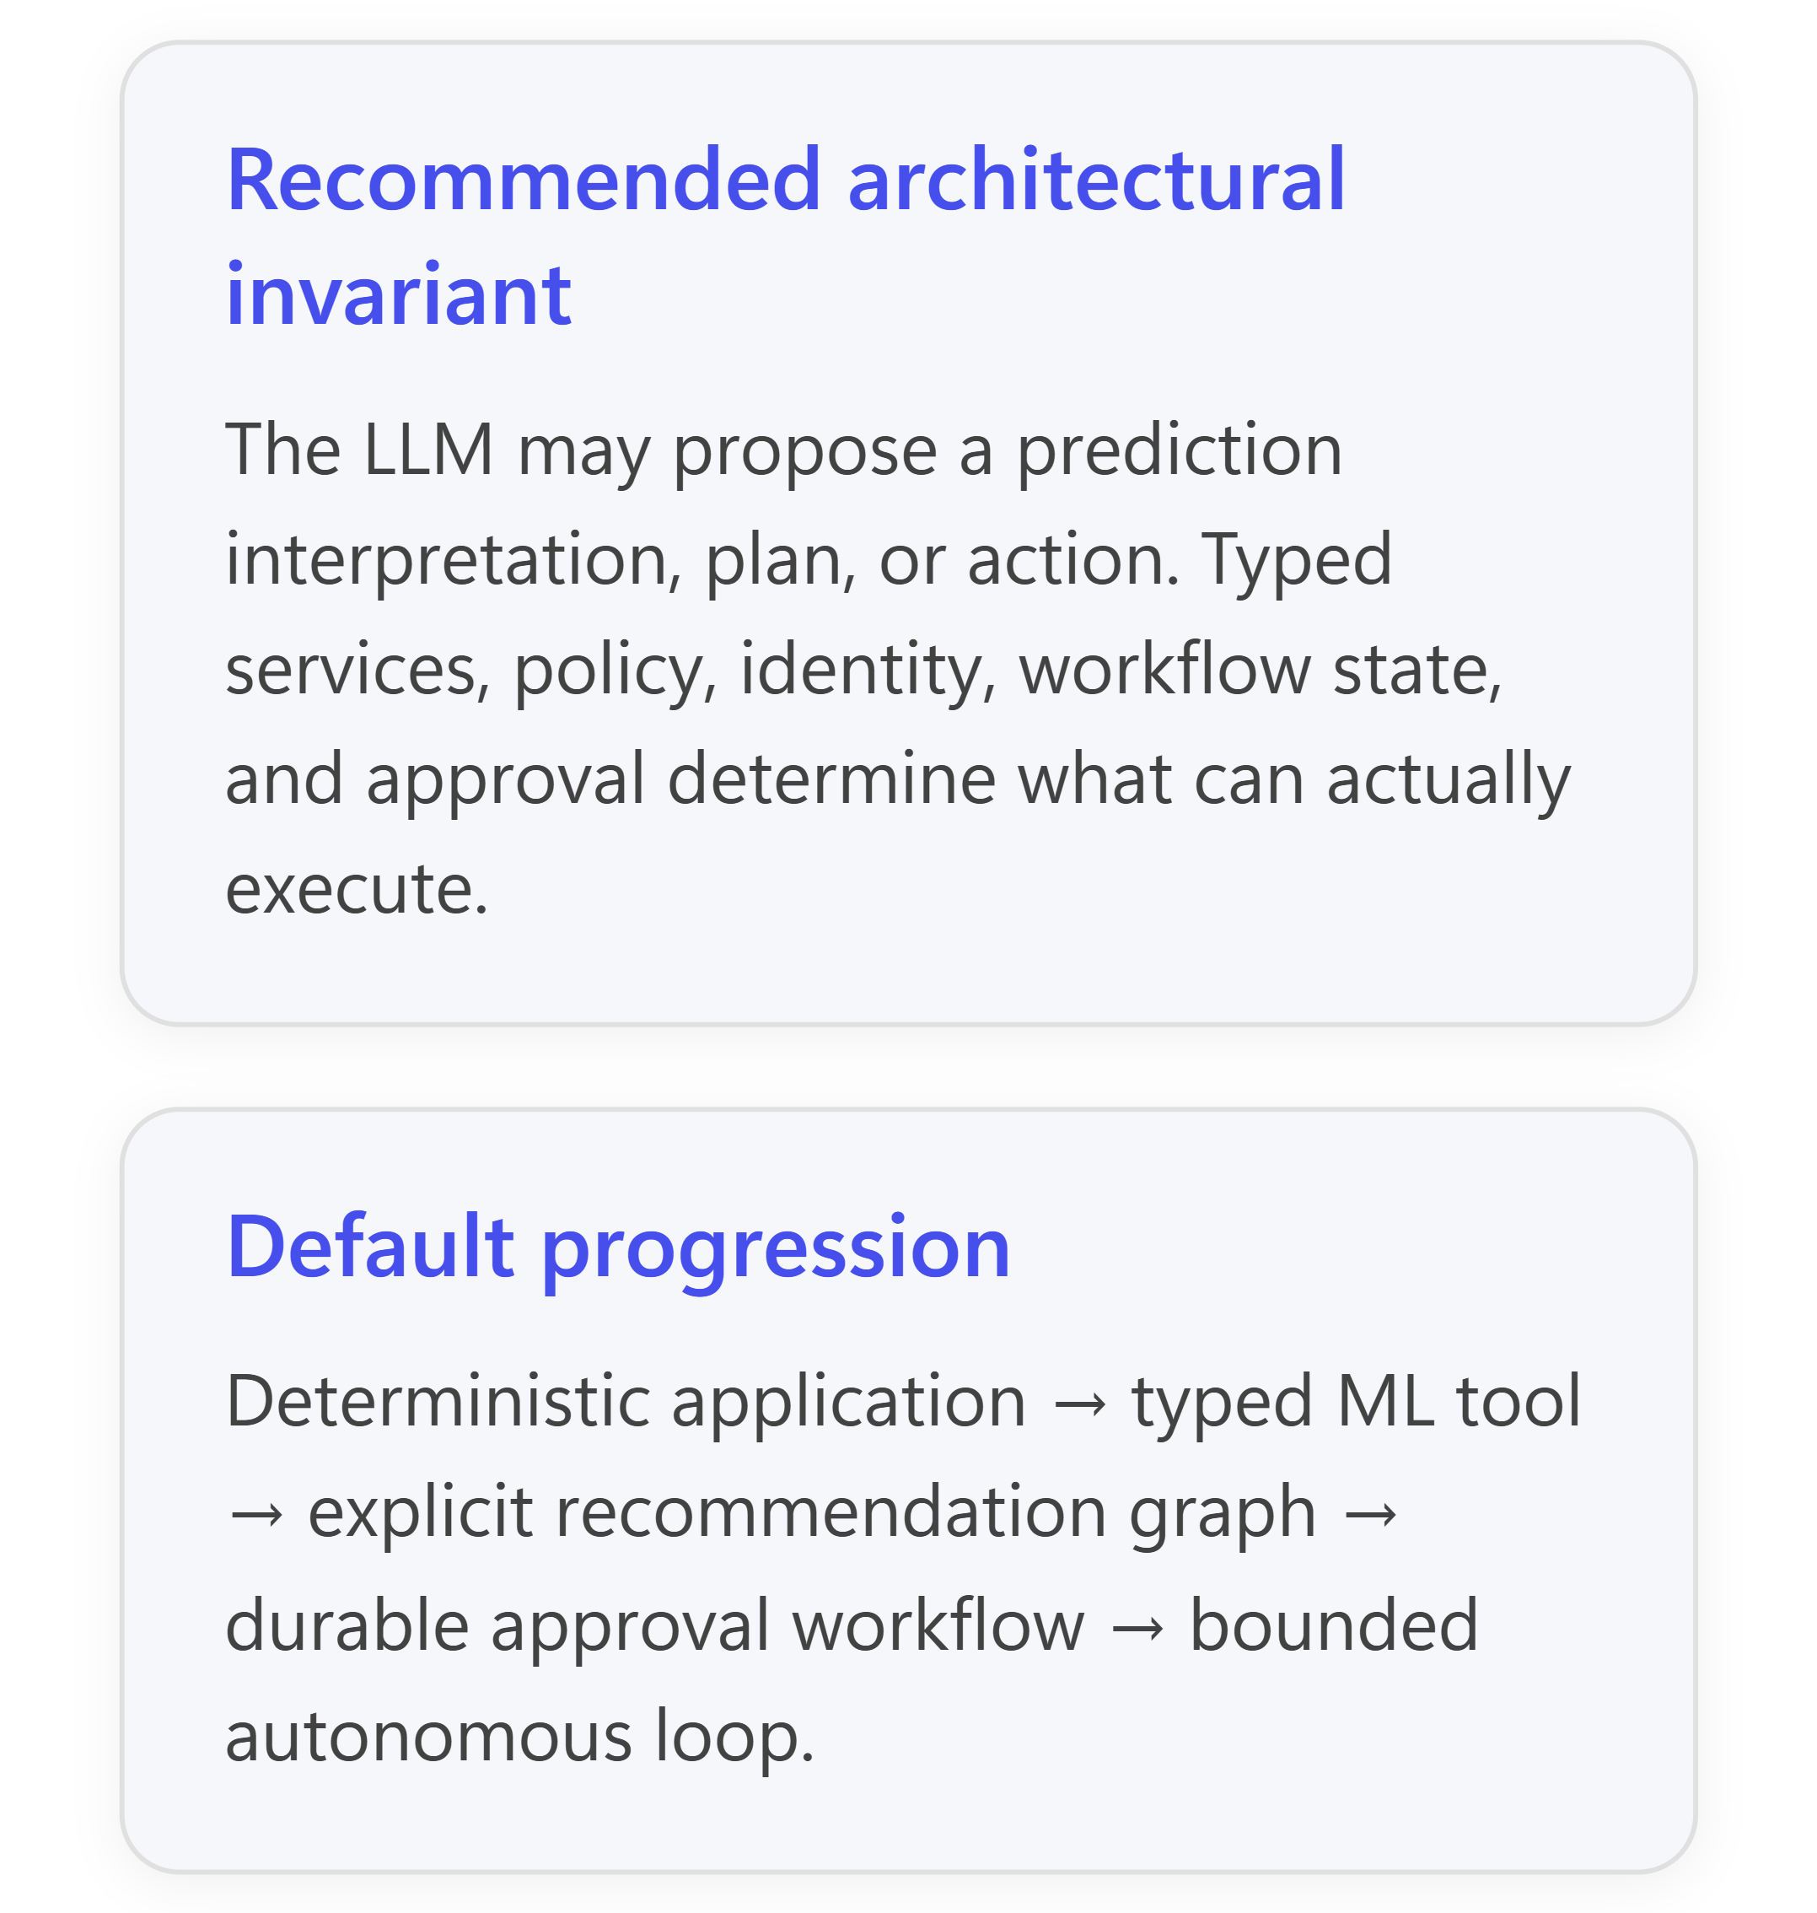

Recommended default stacks

Phase 1 — AI Assistant
Pragmatic default
- Application: FastAPI, ASP.NET Core, Spring Boot, or Node/TypeScript; Pydantic/JSON Schema or equivalent for outputs.
- LLM: a managed model through Microsoft Foundry Models, Amazon Bedrock, or Google Model Garden. Managed catalogs provide multiple hosted model choices and evaluation/deployment integration without initially operating inference infrastructure. [learn.microsoft.com], [docs.aws.amazon.com], [docs.cloud...google.com]
- RAG: PostgreSQL + pgvector if documents, metadata, access rules, and application data naturally belong together; use PostgreSQL full-text search plus vector retrieval and reciprocal-rank fusion. pgvector supports exact and approximate search, HNSW/IVFFlat, filtering, hybrid retrieval, and reranking patterns.
- Observability: OpenTelemetry-compatible application traces plus Langfuse, Arize Phoenix, or MLflow tracing/evaluation.
- Security: existing enterprise identity; retrieval authorization before context construction; source URL/document ID/chunk ID on every retrieved passage.
Alternatives. Choose Azure AI Search, Amazon Bedrock Knowledge Bases/OpenSearch, or Google’s managed search/vector services when connectors, hybrid ranking, scale, or permission-aware enterprise content justify a separate search platform. Azure AI Search supports hybrid retrieval, semantic ranking, citation metadata, security trimming, and permission-aware knowledge sources; Bedrock Knowledge Bases supports managed ingestion, ACL filtering, reranking, and citations.
Why this fits: Phase 1 needs reliability and evidence, not planning autonomy. A conventional request pipeline is easier to test and operate than an agent loop.

Phase 2 — Prediction-aware Assistant
Add, do not rebuild:
- Model lifecycle: MLflow Tracking + Model Registry.
- Serving: BentoML for a small Python-centered deployment; KServe for a Kubernetes platform; Ray Serve when multi-model composition or distributed Python serving is material; or managed Azure Machine Learning, SageMaker AI endpoints, or Google managed model endpoints. KServe provides a standardized cross-runtime inference protocol; BentoML focuses on portable inference services; Ray Serve emphasizes framework-neutral, composable online serving. [kserve.github.io], [docs.bentoml.com], [docs.ray.io]
- Feature management: start with versioned SQL/dbt/Spark transformations. Introduce Feast or a managed feature store only for reused features, point-in-time correctness, or low-latency online features. Azure, AWS, and Google managed stores all address feature reuse and online/offline serving consistency, though their data models differ. [learn.microsoft.com], [docs.aws.amazon.com], [docs.cloud...google.com]
- Monitoring: Evidently, Arize, WhyLabs, or custom drift/calibration jobs plus platform metrics. For new AWS customers, do not make SageMaker Model Monitor the default: AWS documentation states it is no longer open to new customers and will not receive new features. [docs.aws.amazon.com], [learn.microsoft.com]
Mandatory prediction contract
1 {
2 "prediction_id": "immutable-request-id",
3 "model_name": "demand_forecast",
4 "model_version": "2026-09-01",
5 "prediction": 0.73,
6 "unit_or_class": "probability_of_delay",
7 "uncertainty": {
8 "type": "prediction_interval",
9 "lower": 0.61,
10 "upper": 0.82,
11 "confidence": 0.90
12 },
13 "feature_as_of": "2026-09-11T06:00:00Z",
14 "valid_until": "2026-09-12T06:00:00Z",
15 "warnings": [],
16 "schema_version": "1.0"
17 }
The orchestrator passes this object unchanged to decision logic and stores it with the trace. The LLM receives a read-only serialization and may explain it; it must not recalculate, round into a different decision category, or overwrite prediction fields. KServe’s model/version/request metadata provides a portable base, while the domain envelope above adds uncertainty, freshness, and business semantics. [kserve.github.io], [mlflow.org]

Phase 3 — Recommendation Agent
Pragmatic default: LangGraph + Temporal-ready interfaces + OPA + OR-Tools + existing Phase 2 services.
- Use LangGraph as an explicit state graph, with deterministic nodes for retrieval, prediction, rules, optimization, and validation; reserve LLM nodes for query interpretation, ambiguity resolution, and explanation. LangGraph supports persistence, human interrupts, deterministic/agentic mixing, and model-neutral use independent of LangChain. [docs.langchain.com], [learn.microsoft.com]
- Put policy in OPA—or DMN when business analysts need decision tables—and optimization in OR-Tools/Pyomo/HiGHS. The LLM formulates candidate objectives or explains tradeoffs; validated application code supplies solver variables and constraints. [openpolicyagent.org], [github.com]
- Introduce reranking only after measuring baseline retrieval. Evaluate lexical-only, vector-only, hybrid/RRF, and hybrid plus cross-encoder using a query–relevant-document set. Qdrant explicitly recommends evaluation-based fusion weighting; OpenSearch provides score- and rank-based hybrid processors.
Viable alternatives: Microsoft Agent Framework, Google ADK, LlamaIndex Workflows for RAG-heavy applications, or Strands. On AWS, Strands plus AgentCore is a coherent managed path; AgentCore separates runtime, gateway, identity, memory, sandboxed code, observability, and evaluation capabilities.
New components versus Phase 2: explicit orchestration state, decision service, policy/solver versioning, read-only tool catalog, trajectory evaluation, and recommendation outcome capture.

Phase 4 — Human-approved Agent
Pragmatic default: Temporal as the durable control plane; LangGraph or another agent framework as an analysis worker.
The workflow should persist the approval request, evidence snapshot, approver identity, decision, intended command, idempotency key, timeout, and final result. Temporal’s event history, durable timers, signals, retries, and idempotent-activity guidance directly support long-running approvals; Camunda is preferable where BPMN/DMN, business-readable process models, and built-in task management are primary requirements.
Managed equivalents: Azure Logic Apps/Durable Functions, AWS Step Functions, or Google Cloud Workflows can own approval state when cloud alignment outweighs portability. Keep the tool APIs portable even if the workflow engine is not.
Approval is not a chat message. It is a signed/attributed state transition over a specific frozen action proposal. Revalidate authorization, policy, freshness, and preconditions immediately before execution; reject stale approvals.

Phase 5 — Autonomous Agent
Default architecture: keep the Phase 4 workflow and remove the approval step only for explicitly classified action types. Add:
- event bus or outcome feed;
- policy-controlled action budgets and maximum loop count;
- sandboxed execution for generated code;
- tool-specific service identities and short-lived tokens;
- idempotency and deduplication store;
- pre-action state check and post-action verification;
- compensating transaction or rollback handler;
- shadow mode, canary rollout, circuit breaker, and kill switch.
MCP is useful for tool discovery and interoperability, but it is not itself a security boundary. Its current authorization specification uses OAuth-based resource/audience binding and least-privilege scopes, but the viewed document is explicitly a draft; place MCP servers behind an API/tool gateway and enforce authorization again in downstream services. [modelconte...rotocol.io], [genai.owasp.org]

Agent and workflow framework comparison
Approach | Strengths | Constraints and best fit | 2026 assessment
Temporal / Camunda | Durable state, retries, timers, approvals, audit-oriented workflows; Camunda adds BPMN/DMN and task management. | Not an LLM reasoning framework. Embed agent calls as activities/service tasks. | Production default for Phases 4–5.
LangGraph | Low-level state graphs, persistence, streaming, HITL, deterministic plus agentic nodes; broad model/tool ecosystem. [docs.langchain.com], [mlflow.org] | Requires the team to design state, retry, deployment, and governance conventions. | Strong cloud-neutral default for Phase 3.
Microsoft Agent Framework | Agents, typed tools, middleware, sessions, graph workflows, telemetry, MCP, HITL; successor to Semantic Kernel and AutoGen. [learn.microsoft.com], [github.com] | Fast-moving platform; evaluate language-specific maturity and pin versions. Go remains less complete than Python/.NET in current documentation. | Strong Microsoft/.NET option; production-capable with disciplined versioning.
Google ADK | Python/TypeScript/Go/Java/Kotlin, graph workflows, dynamic routing, tools, evaluation, and managed deployment options. [docs.cloud...google.com], [adk.dev] | Best integrated with Google’s agent platform, although the framework is open source. | Strong GCP option; ADK 2.0 graph workflows are current and still evolving.
OpenAI Agents SDK | Typed Python/TypeScript, tools, handoffs, guardrails, human review, tracing, resumable state, and sandbox options. | Application owns deployment, storage, and approval; not a replacement for a durable business-workflow engine. | Good code-first SDK when OpenAI APIs are acceptable.
Strands | Lightweight in-process Python/TypeScript library; structured output, provider adapters, MCP, graphs/workflows, A2A, and OpenTelemetry. | No hosted control plane or durable scheduler by itself; pair with AgentCore or Temporal for production runtime concerns. | Good AWS-neutral library with an AWS-first managed path.
LlamaIndex Workflows | Event-driven, async, stateful workflows closely integrated with ingestion and RAG. | Most compelling when retrieval/document processing is the center of gravity. | Viable RAG-centric alternative.
Rule of thumb: use deterministic code for known transformations, a workflow engine for known processes, an optimization engine for constrained choices, and an LLM agent only where the next step genuinely depends on interpreting ambiguous context.

RAG and enterprise-knowledge pattern
Use one retrieval contract across all phases:
- Ingest: immutable source ID/version, parser version, chunk strategy, ACL metadata, timestamps, checksum.
- Retrieve: apply caller authorization before ranking; combine lexical and dense retrieval; preserve scores and query details.
- Rerank: optional top-N cross-encoder/late-interaction stage.
- Return: chunk text, source URI, document/chunk/version IDs, ACL decision, retrieval/rerank scores, and citation label.
- Generate: instruct the model that retrieved text is untrusted evidence, not executable instruction.
- Validate: require citations for factual claims and verify each citation points to supplied context.
Prefer pgvector when relational consistency, SQL, joins, and operational simplicity dominate; prefer a search platform when lexical search, analyzers, facets, relevance tuning, connectors, and ACL-aware enterprise search dominate; prefer a dedicated vector database such as Qdrant, Milvus, or Weaviate when multivector retrieval, specialized filtering, or independent vector scaling materially matters. pgvector and Qdrant both support hybrid patterns, while OpenSearch provides a more complete search pipeline around lexical/vector fusion and filtering.

Observability and evaluation baseline
Measure three systems separately:
- Predictive ML: discrimination/error, calibration, prediction-interval coverage, abstention, feature freshness, data/feature drift, training-serving skew, delayed ground-truth performance, model/version usage, latency, and failures.
- RAG/LLM: retrieval recall@k and nDCG, citation precision/coverage, groundedness, completeness, abstention, safety, tokens, cost, latency, and model/prompt/index versions.
- Agent/action: task success, expected versus actual trajectory, tool selection and arguments, policy denials, approval rate, execution success, duplicate prevention, rollback rate, and business outcome.
Use offline golden sets for releases, shadow traffic for model/prompt changes, sampled online evaluation for production, and human adjudication to calibrate LLM judges. Microsoft Foundry distinguishes end-to-end task evaluation from process/tool-call evaluation; AgentCore supports on-demand, batch, and continuous online evaluation over production traces.

Minimal proof of concept and production target

Minimal proof of concept
FastAPI/ASP.NET → managed LLM → PostgreSQL + pgvector → MLflow → optional BentoML prediction API → Langfuse/Phoenix/OTel.
Do not add a feature store, agent framework, policy engine, workflow engine, separate vector database, or self-hosted LLM until a concrete requirement appears.

Vendor-neutral production target
Application/API gateway → explicit agent graph → retrieval service + prediction service → policy/optimization service → durable workflow → approval/action gateway → bounded tools, with OIDC/OAuth identities, secrets manager, OpenTelemetry, centralized audit, MLflow-compatible model lineage, offline/online evaluation, and rollback controls.
For self-hosted models, vLLM provides OpenAI-compatible chat, responses, embeddings, and structured-output APIs, but its own documentation warns that API-key authentication does not protect every endpoint; deploy it behind a hardened reverse proxy/gateway. [docs.vllm.ai], [learn.microsoft.com]

Major technology-selection tradeoffs
Decision | Sensible default | Change the default when…
Open source vs. managed | Managed LLM and cloud databases; open interfaces and evaluation data. | Residency, customization, sustained economics, or infrastructure capability justify self-hosting.
Single cloud vs. portable | Optimize for one cloud operationally, but preserve portability at service contracts, telemetry, model artifacts, SQL/object data, and tool APIs. | Regulatory or resilience requirements demand active multi-cloud.
Vector DB vs. search platform | Existing PostgreSQL for simple RAG; search platform for enterprise knowledge. | Dedicated vector scale or multivector retrieval is a demonstrated bottleneck.
Agent framework vs. workflow engine | Agent framework for reasoning; workflow engine for business state and execution. | Never delegate high-impact durability or authorization solely to an agent loop.
Hosted vs. self-hosted models | Hosted models initially. | Privacy, latency, offline operation, specialized fine-tuning, or measured economics justify vLLM/SGLang/KServe operations.
Integrated platform vs. loosely coupled services | Use an integrated platform for the first production release, but retain typed boundaries. | Independent scaling, risk isolation, or cross-cloud requirements justify extraction.
Bottom line: Phase 3 is where an agent framework becomes useful; Phase 4 is where a durable workflow engine becomes essential; Phase 5 should be an incremental policy change over a well-controlled Phase 4 architecture—not a new, unconstrained “autonomous” stack.

